Carbon Footprint across Industries and Individuals

David G. Kinney

Bellevue University

DSC 680 – Professor Catherine Williams

**Abstract**

The effects of climate change are increasingly visible. Storms, droughts, fires, and flooding have become stronger and more frequent [3]. Global ecosystems are changing, including the natural resources and agriculture on which humanity depends. The 2018 intergovernmental report on climate change estimated that the world will face catastrophic consequences unless global greenhouse gas emissions are eliminated within thirty years [4]. Yet year after year, these emissions rise. [1] How does the carbon footprint of a person compare to that of an industry? And does it matter?

Keywords: climate, greenhouse, carbon, footprint, emissions

# Introduction & Hypothesis

It is my subjective observation that a groundswell of concern and effort at the grass roots level is taking hold. More and more, individuals are being steered towards a green(er) lifestyle by gradually reducing their carbon footprint, through efforts such as using less gas and electricity, buying less or no plastic bottles and generating less landfill waste. However, it is my hypothesis that individual effort likely pales in comparison to what is required of major industries notorious for large volumes of greenhouse gas emissions, *the* major cause of adverse climate change.

## Discussion

The United States Environmental Protection Agency (EPA) tracks total U.S. emissions by publishing the Inventory of U.S. Greenhouse Gas Emissions and Sinks. This annual report estimates the total national greenhouse gas emissions and removals associated with human activities across the United States. The data is separated into categories for Transportation, Electricity production, General industry, Commercial and Residential, Agriculture, and Land use. In addition, the EPA also provides the Greenhouse Gas Inventory Data Explorer–an interactive tool that provides access to data from the EPA's annual Inventory of the U.S. Greenhouse Gas Emissions and Sinks. It can be used to create customized graphs, examine trends over time, and download data. [5] Graphing the data for the years 1990 through 2019 by economic sector highlights the disparity between electricity generation, transportation and industry, and residential emissions.

The picture becomes even more bleak when analyzed on a global level. Global carbon emissions from fossil fuels have significantly increased since 1900. In fact, since 1970, CO2 emissions have increased by about 90%, with emissions from fossil fuel combustion and industrial processes contributing about 78% of the total greenhouse gas emissions increase from 1970 to 2011. Agriculture, deforestation, and other land-use changes have been the second-largest contributors.[8]

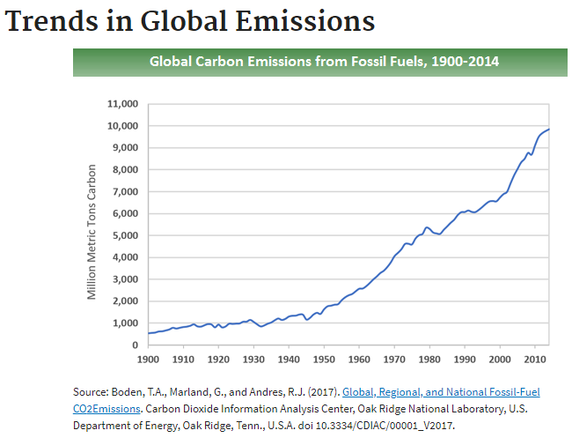

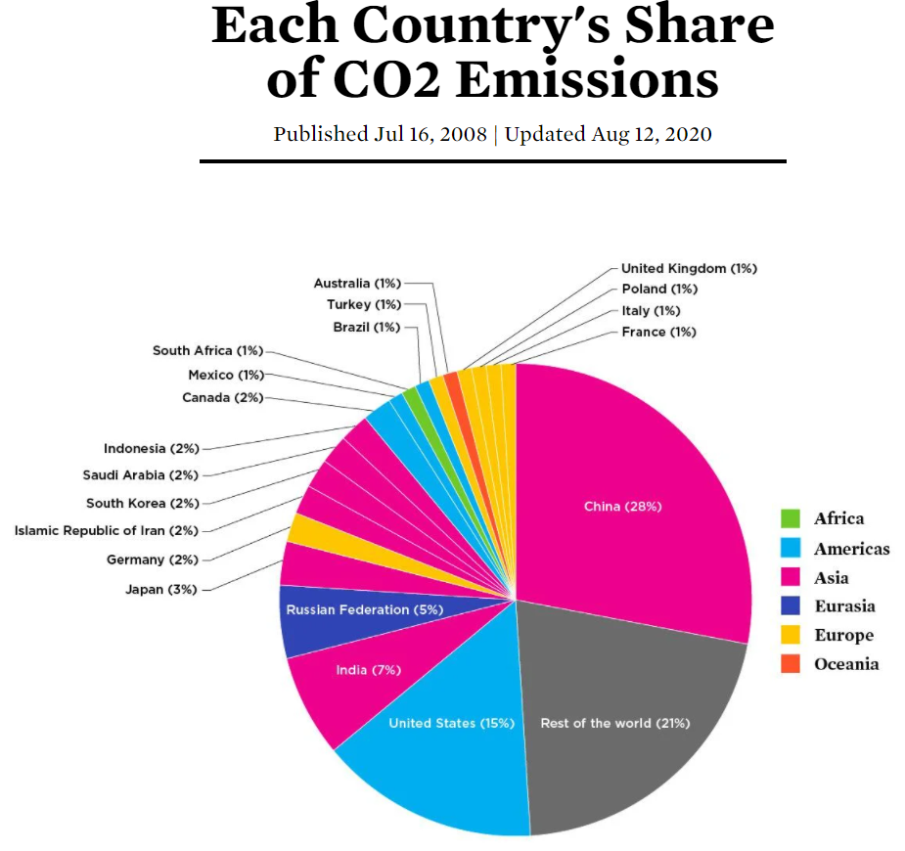

However, much of the blame lies right here in the good old United States. While this country has lately made a sport of accusing China of all the ills of the world, this country comes in second in the category of most CO2 emitted in recent years.

Source: <https://www.ucsusa.org/resources/each-countrys-share-co2-emissions>

### **Research**

Overall, residential gas emission pales in comparison to most industries, electricity generation being the most extreme example, followed by agriculture, deforestation and gas emissions emitted from fossil fuels burned for road, rail, air, and marine transportation. Globally, China accounts for 30% of emissions from fossil fuel combustion with the United States second, account for 15%. [8]

##### **Conclusions**

Admittedly, my intention of this project was to present factual evidence that the effects of residential gas emissions are so much less than industry that it is relatively pointless for residents of the planet to curb their lifestyles considering the insignificant effect it will have in the great scheme of things.

But then I came across a blog post by Stephanie Willis on Towards Data Science:

*Often when I think about climate change and what we might do to mitigate it I become forlorn with the hopelessness of it all. It seems so important and yet so insoluble.*

*Emitting large amounts of CO2 gives us an incredible lifestyle. When we emit there is no immediate feedback mechanism — no way for us to directly feel the cost of our emissions. What’s more, the cost is mostly born by other people. The big, immediate benefits and the lack of direct negative feedback make it hard to persuade ourselves, or our governments, to curb emissions. So hard in fact that I think it is tempting to give it up as a bad job and to get on with our lives. We feel like there is no chance our governments and industries will make the changes needed to meet the Paris Agreement’s aim of limiting global warming to ‘well below 2°C above pre-industrial levels’ — and so we give up.*

***But we shouldn’t. Because 2°C is better than 3°C and 3°C is better than 4°C.*** *[8]*

So, what can Data Scientists do?

**Better Climate Predictions** - *Climate informatics* covers a range of topics from improving prediction of extreme events such as hurricanes, paleoclimatology, reconstructing past climate conditions using data collected from things like ice cores, climate downscaling, or using large-scale models to predict weather on a hyper-local level, and the socio-economic impacts of weather and climate. AI can also unlock new insights from the massive amounts of complex climate simulations generated by the field of *climate modeling*, which has come a long way since the first system was created at Princeton in the 1960s. Of the dozens of models that have since come into existence, all represent atmosphere, oceans, land, cryosphere, or ice. [10]

**Showing the effects of extreme weather** – I personally became involved with MILA in a roundabout way. I began corresponding with Sasha Luccioni, a Postdoc working on a Python library to calculate the carbon footprint of training Machine Learning models. I did some beta testing of the library and provided feedback and did a few pulls of the library on Github. They have done some interesting (and sobering) work with GANs (General Adversarial Networks) to simulate what homes are likely to look like after being damaged by rising sea levels and more intense storms. [11]

**Measuring where carbon is coming from -** Carbon Tracker is an independent financial think-tank working toward the UN goal of preventing new coal plants from being built by 2020. By monitoring coal plant emissions with satellite imagery, Carbon Tracker can use the data it gathers to convince the finance industry that carbon plants aren't profitable. [10]

**My final conclusions:**

* It is factually evident that residents produce considerably less greenhouse gas emissions than large industry.
* All of us can provide intangible pressure through such efforts as the [Union of Concerned Scientists](https://www.ucsusa.org/climate).
* As Data Scientists, we possess the skills to [drive climate change](https://www.nationalgeographic.com/environment/article/artificial-intelligence-climate-change).

**References**

[1] [arXiv:1906.05433](https://arxiv.org/abs/1906.05433)**[cs.CY]**

[2] Sources of Greenhouse Gas Emissions <https://www.epa.gov/ghgemissions/sources-greenhouse-gas-emissions>

[3] Christopher B Field, Vicente Barros, Thomas F Stocker, and Qin Dahe. Managing the risks of extreme events and disasters to advance climate change adaptation: special report of the intergovernmental panel on climate change. Cambridge University Press, 2012.

[4] IPCC. Global warming of 1.5 ◦C. An IPCC special report on the impacts of global warming of 1.5 ◦C above pre-industrial levels and related global greenhouse gas emission pathways, in the context of strengthening the global response to the threat of climate change, sustainable development, and efforts to eradicate poverty [V. Masson-Delmotte, P. Zhai, H. O. Portner, D. Roberts, J. Skea, P.R. Shukla, A. Pirani, Y. Chen, S. Connors, ¨ M. Gomis, E. Lonnoy, J. B. R. Matthews, W. Moufouma-Okia, C. Pean, R. Pidcock, N. Reay, M. Tignor, T. ´ Waterfield, X. Zhou (eds.)]. 2018.

[5] Greenhouse Gas Inventory Data Explorer <https://cfpub.epa.gov/ghgdata/inventoryexplorer/>

[6] Carbon Emissions C. Bouley Jan 2020 <https://towardsdatascience.com/tagged/carbon-emissions>

[7] Fighting the Climate Crisis: 6 Future Game-Changers Made Possible by Deep Learning D. Fleury Jan 2019 <https://towardsdatascience.com/fighting-the-climate-crisis-5-future-gamechangers-made-possible-by-deep-learning-f301f29f632c>

[8] Global Greenhouse Gas Emissions Data <https://www.epa.gov/ghgemissions/global-greenhouse-gas-emissions-data#Reference%201>

[9] Concerning Climate S. Willis Sept 2017 Towards Data Science <https://towardsdatascience.com/https-medium-com-stephaniewillis808-concerning-climate-5a6b923eb8eb>

[10] How Artificial Intelligence can tackle climate change J. Snow July 2019 National Geographic <https://www.nationalgeographic.com/environment/article/artificial-intelligence-climate-change>

[11] Visualizing Climate Change <https://mila.quebec/en/ai-society/visualizing-climate-change>